Trường: THCS Nguyễn Văn Bé

ÔN TẬP KIỂM TRA LẠI NH 2020 – 2021
MÔN: ANH VĂN 8

- Multiple Choice
  - It’s very interesting _______________________around the world. (to travel/ travel/ traveling/ to traveling)
  - The Statue of Liberty was presented ____________________the United States by France in 1876. (for/ of/ in/ to)
  - The weather is fine and the sky is______________________. (wet/ cloudy/ cold/ cloudless)
  - Do you mind _______________________________me a cup of tea? (get/ to get/ getting/ to getting)
  - Would you mind if I ________________________________ here? (sit/ to sit/ sat/ to sitting)
  - Do you mind if I ___________________________you? (help/ helped/ to help/ to helping)
  - Mai is _______________________________asking me for money. (always/ usually/ sometimes/ often)
  - The boy____________________________ into the room is Phong. (walks/ is walking/ walking/ was walking)
  - New Year’s Day is celebrated _____________________January the first. (in/ on/ at/ since)
  - The Pyramids are very __________________________in the world. (interested/ guided/ famous/ wonderful)
  - Santa Claus is based on the ______________________of Saint Nicholas. (picture/ description/ decoration/ design)
  - We usually __________________________our homes before the Tet holidays. (sell/ build/ decorate/ design)
  - Ha Long Bay is one of our natural________________________________(places/ wonders/ jungles/ caves)
  - That supermarket is always ________________________________with people. (full/ crowded/ happy/ keen)
  - The area___________________ Angkor Wat is called Angkor Thom. (moving/ situating/ compiling/ surrounding)
  - What do you do, Jane? – Oh, I’m a_____________________________(tourist/ cooker/ florist/ character)
  - Would you mind if I smoked? - ______________(Please don’t/ I’d rather you didn’t/ Yes, I did/ no, I didn’t)
  - Do you mind if I take a photo? - ___.(I’m sorry, you can’t/ Please go ahead/ That would be nice/ Yes, I don’t mind)
  - Why don’t you do your homework, Linh? - ________________________________(Because I don’t/ Don’t forget/ I promise I won’t do that again/ I’m sorry, I’ll do it now)
  - Viet Nam is one of the leading rice _________________ in the world. (exporters/ importers/ users/ judges)
  - Are you ____________________ in this festival? (keen/ fond/ interested/ interesting)
  - She often __________________________with a cup of coffee and a novel. (drinks/ relaxes/ plays/ reads)
  - The ______________ are keen on the pottery made in Bat Trang. (sightseer/ tourists/ contestants/ competitors)
  - Look! There a plane flying _______________. (below/ overhead/ above/ between)
  - The __________________ sold at that shop are imported from Japan. (produce/ production/ producers/ products)
  - She fell off her bike and became _____________________. (conscious/ awake/ unconscious/ sleepy)
  - Thanks to his _________________, the police could find the missing child easily. (description/ experience/ recognition/ certainty)
  - We should protect our _______________________. (sightseeing/ forests/ competitions/ worlds)
  - Hue is ______________________ as a World Heritage Site by UNESCO. (organized/ recognized/ named/ used)
  - Every year, farmers have to ______________ nature to have good crops. (play/ grow/ work/ fight)
  - Who _______________ this Christmas card for you? (sold/ designed/ painted/ planted)
  - They visited the __________ Institute in Nha Trang last week. (tribal/ traditional/ religious/ oceanic)
  - I _______________________________to her about our plan. (just talk/ just talked/ have just talked/ has talked)
  - Her father ________________________that computer last week. (buy/ buys/ has bought/ bought)
  - The men ____________________ the house. (has already built/ have already built/ already built/ )
  - The student ___________________________ a book in blue is Phong. (is wrapping/ wraps/ wrapping/ wrapped)
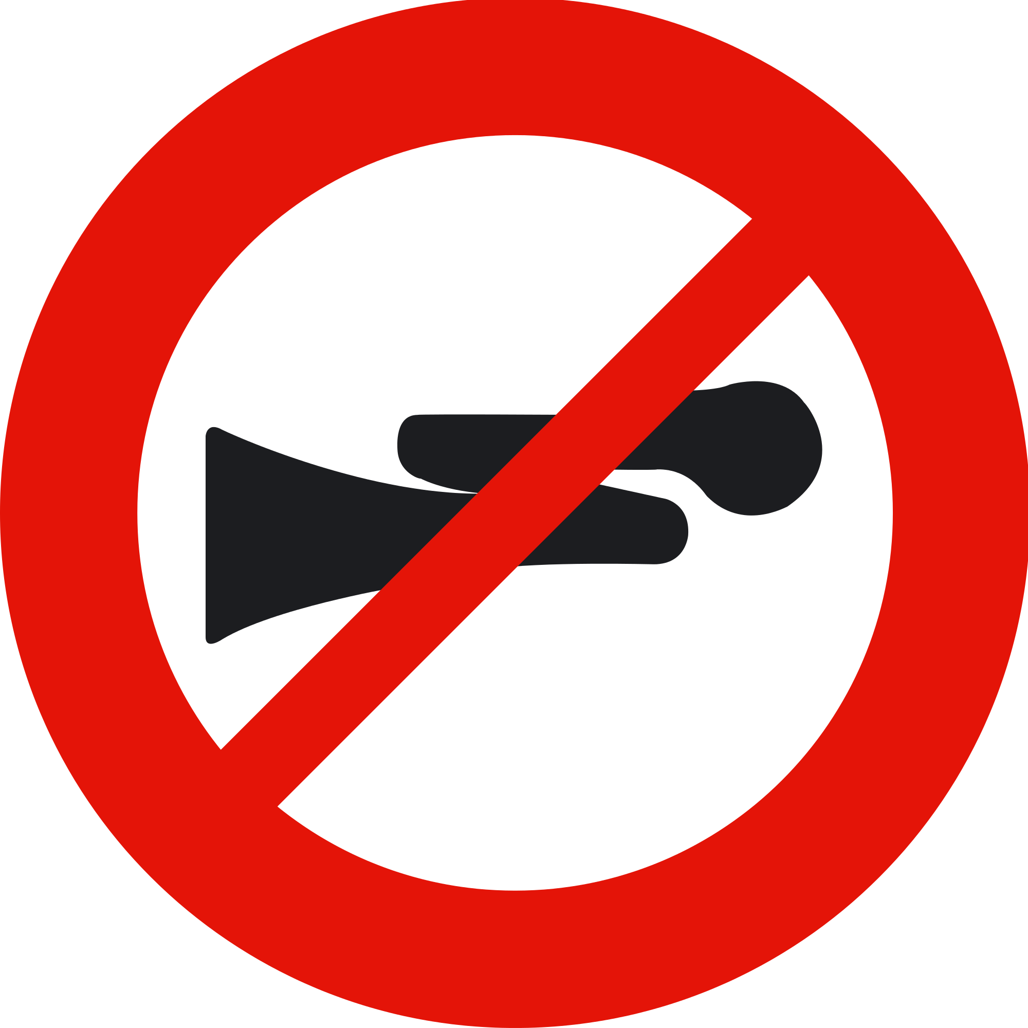
  - The sign means:
      - You can’t play your horn in this area! b. You’re not allowed to play trumpet.
c. You mustn’t use horn in this area. d. You must use horn in this area.
  - The sign means:

      - Plug electric appliances after use to save electricity.
b. Unplug electric appliances after use to save electricity.
c. Don’t use electric appliances after use to save electricity.
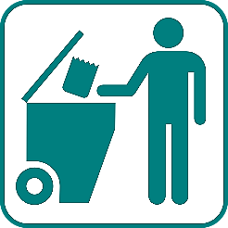
d. Be careful with electricity!
  - The sign means:
      - Put your things here! b. Please put trash into the bin!
c. Open the bin and throw trash into it! c. Keep our city clean!
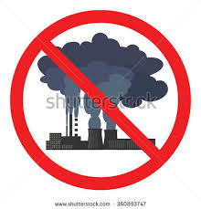
  - The sign means:
      - Stop smoking! b. Stop polluting the air!
c. Stop the trees! d. You mustn’t build factories here.
II. Rearrange the words and phrases in the correct order:
- our teacher. / know / very well / We / talking to / the man
We
- told / she / My mother / was / with my success / me / very pleased
My mother
- I / their homework. / they / When / were doing / arrived,
When
- wanted / more attractive. / The students / their school ground / to make
The students
- unhappy / a poor mark / It / at any subject. / makes us / to get
It
- your computer / if I / for some minutes? / Would you mind / used
Would you mind
- written / in Vietnam. / by Mr. Jones / places of interest / The book / is about
The book
- some advice / Would you mind / gave / on studying English? / if I
Would you mind
- said that / at the festival. / Hoa / wanted / to look / she / nice / her room
Hoa
- on TV / around Ba Be Lake / shown / last night/ about wildlife / is / The natural program
The natural program
- by my brother / the first prize / won / taken / in the art contest. / The picture
The picture
- suddenly began / while / in the garden. / Laura / to rain / It / was sitting
It

III. Supply the correct form of the words in the blanks:
- Ha Long Bay is one of the tourist ________________________________ in the world. (attract)
- Compost can be used as a wonderful ________________________. (fertilize)
- The building ___________________________ at the corner of the street is very modern. (locate)
- We should buy _________________________________ things to save the environment. (recycle)
- Most of glass is ______________________________________________________. (recycle)
- Two _____________________________ from each group will take part in the game. (represent)
- The villa is _____________________________________ situated by the riverside. (attract)
- ________________________________ mustn’t touch the paintings hung on the walls. (Sightsee)
- Her father is one of the best _______________________ I’ve ever known. (design)
- Tourists are always _______________________ in hotel _____________________. (interest/ accommodate)
- The girl who performs most ________________________ will win the prize. (attract)
- They took the ___________________ man to hospital in an ambulance. (injure)
- Did you say China is the country __________________ the most oil in the world? (import)
- We took a _________________________________ tour in the morning. (sightsee)
- Our school is ______________________ near the crossroads Le Quang Dinh and Nguyen Van Dau. (situate)
- She is good at English. She speaks English __________________________. (nature)
- They collect old can and bottled and send them for _________________________. (recycle)
- Angkor Wat used to be a ___________________________________ center. (religion)
- Farmers shouldn’t use too much ___________________________ on their vegetables. (fertilize)
- I can take you there but I’m _____________________ that it is opened today. (certainly)
IV. Finish the second sentences. Keep its meaning similar to the above:

- Venezuela is a country which exports a lot of oil.
→ Venezuela is
- They are liquids which are used to clean cars.
→ They are
- This is an area in which people growing bananas.
→ It’s
- He is reading a book which has one hundred pages.
→ He is reading
- “Do you understand these lessons, Hoa?”
→ Ba asked Hoa
- The teacher said: “Do you know the answer to this question, children?”
→ The teacher asked
- “Can you go to the supermarket with me now, Trung?” said Mrs. Lien.
→ Mrs. Lien asked
- You have to do your homework every day.
→ Your homework
- Ba should do it carefully.
→ It
- The mechanics must fix the cars in two days.
→ The cars
- She brushes her teeth very carefully.
→ Her teeth
- During my stay in Da Lat, I visited a lot of tourist attractions.
→ While I
V. Reading Comprehension
A1. Read the following passage and then decide whether the statements that follow are True or False
Our environment is getting worse day by day, and we are suffering for other peoples and our mistakes. It’s getting harder and harder for our families to stay healthy with all the bad things we are around every day. We are affected by our environment, and more people are getting sicker and sicker. This could affect our families and our future one day.
All of the bad things are preventable if you just take the time to think about it. “Most cleaners use a chemical called perchloroethylene” (PERC), which can pollute the air in your home. Use water instead. Most clothes labeled as “dry clean only” can be washed with water.” (Environment). There are many things our teens and families can do to help prevent diseases. We could hand wash our clothes, ride a bike to school or work instead of a car to prevent pollution and could hurt the environment. Teens need to do this because they are the worst about it. All they want to do is hurt the environment and don't second guess themselves. We need to change that so our home and economy make the world a better place.
There can be a solution to helping our environment. If we reach out to people who don't care about our environment, we could change their point of view of things. We could tell them how bad things are in our world and that could change what their prospective on things. What could you do to help our world? And how could we join together as one country to help our world and make it a better place for all of us to live?
- The environment is becoming dirtier and dirtier. ______________
- Our health is affected by the environment. ______________
- It’s impossible to stop things that harm the environment. ______________
- Persuading people to stop going to work by car or motorbike is also a good way to protect the environment.
- The best topic for the passage is : ______________
a/ Why the environment is polluted b/ Let’s pollute the environment
c/ Pollution d/ How to prevent the world from pollution
A2. Read the following passage and then decide whether the statements that follow are True or False
Phong Nha-Kẻ Bàng is home to the largest cave in the world and covers 300 different grottoes and caves. Before Sơn Đoòng Cave was found, Phong Nha Cave was regarded by British Caving Association as the top cave in the world due to its top four records: the longest underground river, the highest and longest cave, broadest and most beautiful fine sand beaches inside the caves, and the most spectacular stalagmites and stalactites.In the survey conducted in April 2009, the British cave explorers discovered 20 new caves with total length of 56 km, including world's largest cave Son Doong. According to the assessment of UNESCO, "The karst formation of Phong Nha-Kẻ Bàng National Park has evolved since the Palaeozoic (some 400 million years ago) and so is the oldest major karst area in Asia" and "Phong Nha displays an impressive amount of evidence of earth's history. It is a site of very great importance for increasing our understanding of the geologic, geomorphic and geo-chronological history of the region.

- There are many caves in Phong Nha- Ke Bang. __________  - People can swim inside Phong Nha Cave. ____  - Mountain climbing is popular in Phong Nha. ____  - Phong Nha-Ke Bang Park was formed about 100 years ago. ____________ | - The topic of the passage is: a/ Phong Nha Cave b/ The foundation of Phong Nha Cave c/ A National Park d/ Son Doong Cave  - The nearest in menaing with “discovered” is: a/ made b/ found c/ built d/ established
A3. Read the following passage and then decide whether the statements that follow are True or False

Mid-autumn festival is called Tet Trung Thu in Vietnam. It is organized in the middle of the autumn which is the eighth lunar month of the year. Mid-autumn festival is the festival of the children.
From the beginning of the month, people have prepared for the festival with colorful and different shape lanterns. Moon cakes or mid-autumn cakes are also prepared along with the various toys for children. There are many traditional toys that the most typical ones are star lantern, paper doctor human, animal shape lantern, etc. Children carry the lanterns, walk from streets to streets in the funny sounds of their singing every evening. When the principle time of the festival comes, there are groups of lion dance with crowded drums and cymbals. On this occasion, to enjoy the beauty of the moon, there are many activities are organized. Adults and children have their own way of celebrating.
- Mid-autumn is organized in August. __________________
- Children are the main characters at this festival. __________________
- Children play with their lanterns all day. __________________
- Children enjoy the festival together with their families. __________________
- The best topic for the passage is: __________________
a/ The autumn b/ A festival for children c/ Festivals d/ A famous festival
- Which one is nearest in meaning with “principle”? __________________
a/ good b/ busy c/ joyful d/ main

B1. Choose the most suitable word that best fits the blank space in the following passage
One of the (1)____________ activities in Vietnamese Tet festivals is rice cooking competition. A rice cooking competition (2)________ to encourage women to take more responsibility in their (3)__________ work. Six people (4)__________ each team take part in this competition. Two people have to (5) __________ rice from husk. Then a small quantity of rice is taken for cooking just enough for a bowl of rice. Rice must (6)_______ with straw fire, the burning straw enveloping the whole pot in order (7)__________ that the rice is well cooked.
In the end, each team’s rice is (8)____________ by the judges and the winning team is announced.
- a/ mean b/ meaning c/ meaningful d/ meaningless
- a/ hold b/ held c/ is holding d/ is held
- a/ natural b/ traditional c/ usual d/ attractive
- a/ in b/ from c/ of d/ at
- a/ separate b/ cook c/ fetch d/ make
- a/ cook b/ to cook c/ be cook d/ be cooked
- a/ ensure b/ to ensure c/ ensured d/ ensuring
- a/ eaten b/ treated c/ recycled d/ tasted

B2. Choose the most suitable word that best fits the blank space in the following passage
Tet (Tet nguyên dán) is the Vietnamese New Year. It marks the coming of (1)____ and the new lunar year. The celebrations last three (2)_____. Tet shares many of the same (3)_________ of the Chinese New Year.
Before Tet, streets are filled with shoppers – (4)______ new clothes for children, candies, flowers and decorations for their homes. (5)______ New Year's Eve each home is swept and (6)_______ in red and gold, with yellow "hoa mai" flowers (in southern Vietnam) or peach blossoms "hoa dao" (in the northern part of Vietnam) and with woodcut prints of the new year's zodiac animal. (7)________, each home displays a 5-6m long bamboo pole, stripped of its leaves except the top. It is decorated with (8)________ and symbols for good luck and protection from evil spirits.
- a/ spring b/ summer c/ fall d/ winter
- a/ weeks b/ months c/ years d/days
- a/ traditions b/ customs c/ descriptions d/ religions
- a/ selling b/ making c/ buying d/ visiting
- a/ In b/ On c/ From d/ At
- a/ washed b/ painted c/ decorated d/ competed
- a/ Usually b/ Finally c/ Carefully d/ Traditionally
- a/ name cards b/ presents c/ greetings cards d/ food

ĐÁP ÁN THAM KHẢO

I. Multiple Choice

  - It’s very interesting _______________________around the world. (to travel/ travel/ traveling/ to traveling)
  - The Statue of Liberty was presented ____________________the United States by France in 1876. (for/ of/ in/ to)
  - The weather is fine and the sky is______________________. (wet/ cloudy/ cold/ cloudless)
  - Do you mind _______________________________me a cup of tea? (get/ to get/ getting/ to getting)
  - Would you mind if I ________________________________ here? (sit/ to sit/ sat/ to sitting)
  - Do you mind if I ___________________________you? (help/ helped/ to help/ to helping)
  - Mai is _______________________________asking me for money. (always/ usually/ sometimes/ often)
  - The boy____________________________ into the room is Phong. (walks/ is walking/ walking/ was walking)
  - New Year’s Day is celebrated _____________________January the first. (in/ on/ at/ since)
  - The Pyramids are very __________________________in the world. (interested/ guided/ famous/ wonderful)
  - Santa Claus is based on the ______________________of Saint Nicholas. (picture/ description/ decoration/ design)
  - We usually __________________________our homes before the Tet holidays. (sell/ build/ decorate/ design)
  - Ha Long Bay is one of our natural________________________________(places/ wonders/ jungles/ caves)
  - That supermarket is always ________________________________with people. (full/ crowded/ happy/ keen)
  - The area___________________ Angkor Wat is called Angkor Thom. (moving/ situating/ compiling/ surrounding)
  - What do you do, Jane? – Oh, I’m a_____________________________(tourist/ cooker/ florist/ character)
  - Would you mind if I smoked? - ______________(Please don’t/ I’d rather you didn’t/ Yes, I did/ no, I didn’t)
  - Do you mind if I take a photo? - ___.(I’m sorry, you can’t/ Please go ahead/ That would be nice/ Yes, I don’t mind)
  - Why don’t you do your homework, Linh? - ________________________________(Because I don’t/ Don’t forget/ I promise I won’t do that again/ I’m sorry, I’ll do it now)
  - Viet Nam is one of the leading rice _________________ in the world. (exporters/ importers/ users/ judges)
  - Are you ____________________ in this festival? (keen/ fond/ interested/ interesting)
  - She often __________________________with a cup of coffee and a novel. (drinks/ relaxes/ plays/ reads)
  - The ______________ are keen on the pottery made in Bat Trang. (sightseer/ tourists/ contestants/ competitors)
  - Look! There a plane flying _______________. (below/ overhead/ above/ between)
  - The __________________ sold at that shop are imported from Japan. (produce/ production/ producers/ products)
  - She fell off her bike and became _____________________. (conscious/ awake/ unconscious/ sleepy)
  - Thanks to his _________________, the police could find the missing child easily. (description/ experience/ recognition/ certainty)
  - We should protect our _______________________. (sightseeing/ forests/ competitions/ worlds)
  - Hue is ______________________ as a World Heritage Site by UNESCO. (organized/ recognized/ named/ used)
  - Every year, farmers have to ______________ nature to have good crops. (play/ grow/ work/ fight)
  - Who _______________ this Christmas card for you? (sold/ designed/ painted/ planted)
  - They visited the __________ Institute in Nha Trang last week. (tribal/ traditional/ religious/ oceanic)
  - I _______________________________to her about our plan. (just talk/ just talked/ have just talked/ has talked)
  - Her father ________________________that computer last week. (buy/ buys/ has bought/ bought)
  - The men ____________________ the house. (has already built/ have already built/ already built/ has already been built)
  - The student ___________________________ a book in blue is Phong. (is wrapping/ wraps/ wrapping/ wrapped)
  - The sign means:
      - You can’t play your horn in this area! b. You’re not allowed to play trumpet.
c. You mustn’t use horn in this area. d. You must use horn in this area.
  - The sign means:
      - Plug electric appliances after use to save electricity.
b. Unplug electric appliances after use to save electricity.
c. Don’t use electric appliances after use to save electricity.
d. Be careful with electricity!
  - The sign means:
      - Put your things here! b. Please put trash into the bin!
c. Open the bin and throw trash into it! c. Keep our city clean!
  - The sign means:
      - Stop smoking! b. Stop polluting the air!
c. Stop the trees! d. You mustn’t build factories here.

II. Rearrange the words and phrases in the correct order:
- our teacher. / know / very well / We / talking to / the man
We know the man talking to our teacher.
- told / she / My mother / was / with my success / me / very pleased
My mother told me she was very pleased with my success.
- I / their homework. / they / When / were doing / arrived,
When I arrived, they were doing their homework.
- wanted / more attractive. / The students / their school ground / to make
The students wanted to make their school more attractive.
- unhappy / a poor mark / It / at any subject. / makes us / to get
It makes us unhappy to get a poor mark at any subject.
- your computer / if I / for some minutes? / Would you mind / used
Would you mind if I used your computer for some minutes?
- written / in Vietnam. / by Mr. Jones / places of interest / The book / is about
The book written by Mr. Jones is about places of interest in Vietnam.
- some advice / Would you mind / gave / on studying English? / if I
Would you mind if I gave some advise on studying English?
- said that / at the festival. / Hoa / wanted / to look / she / nice / her room
Hoa said that she wanted her room to look nice at the festival.
- on TV / around Ba Be Lake. / shown / last night/ about wildlife / is / The natural program
The natural program shown on TV last night is about the wildlife around Ba Be Lake.
- by my brother / the first prize / won / taken / in the art contest. / The picture
The picture taken by my brother won the first prize in the art contest.
- suddenly began / while / in the garden. / Laura / to rain / It / was sitting
It suddenly began to rain while Laura was sitting in the garden.

III. Supply the correct form of the words in the blanks:
- Ha Long Bay is one of the tourist attractions in the world. (attract)
- Compost can be used as a wonderful fertilizer. (fertilize)
- The building located at the corner of the street is very modern. (locate)
- We should buy recycled things to save the environment. (recycle)
- Most of glass is recyclable. (recycle)
- Two representatives from each group will take part in the game. (represent)
- The villa is attractively situated by the riverside. (attract)
- Sightseers mustn’t touch the paintings hung on the walls. (Sightsee)
- Her father is one of the best designers I’ve ever known. (design)
- Tourists are always interested in hotel accommdation. (interest/ accommodate)
- The girl who performs most attractively will win the prize. (attract)
- They took the injured man to hospital in an ambulance. (injure)
- tourists today. (tour)

IV. Finish the second sentences. Keep its meaning similar to the above:
- Venezuela is a country which exports a lot of oil.
→ Venezuela is an oil - exporting country.
- They are liquids which are used to clean cars.
→ They are car – cleaning liquids.
- This is an area in which people growing bananas.
→ It’s a banana – growing area.
- He is reading a book which has one hundred pages.
→ He is reading a one – hundred – pape book.
- “Do you understand these lessons, Hoa?”
→ Ba asked Hoa if she understood those lessons.
- The teacher said: “Do you know the answer to this question, children?”
→ The teacher asked the children if they knew the answer to that question.
- “Can you go to the supermarket with me now, Trung?” said Mrs. Lien.
→ Mrs. Lien asked Trung if he went to the supermarket with her then.
- You have to do your homework every day.
→ Your homework has to be done every day.
- Ba should do it carefully.
→ It should be done carefully by Ba.
- The mechanics must fix the cars in two days.
→ The cars must be fixed by the mechanics in two days.
- She brushes her teeth very carefully.
→ Her teeth are brushed very carefully.
- During my stay in Da Lat, I visited a lot of tourist attractions.
→ While I was staying in Da Lat, I visited a lot of tourist attractions.
VI. Reading Comprehension
A1. Read the following passage and then decide whether the statements that follow are True or False
Our environment is getting worse day by day, and we are suffering for other peoples and our mistakes. It’s getting harder and harder for our families to stay healthy with all the bad things we are around every day. We are affected by our environment, and more people are getting sicker and sicker. This could affect our families and our future one day.
All of the bad things are preventable if you just take the time to think about it. “Most cleaners use a chemical called perchloroethylene” (PERC), which can pollute the air in your home. Use water instead. Most clothes labeled as “dry clean only” can be washed with water.” (Environment). There are many things our teens and families can do to help prevent diseases. We could hand wash our clothes, ride a bike to school or work instead of a car to prevent pollution and could hurt the environment. Teens need to do this because they are the worst about it. All they want to do is hurt the environment and don't second guess themselves. We need to change that so our home and economy make the world a better place.
There can be a solution to helping our environment. If we reach out to people who don't care about our environment, we could change their point of view of things. We could tell them how bad things are in our world and that could change what their prospective on things. What could you do to help our world? And how could we join together as one country to help our world and make it a better place for all of us to live?
- The environment is becoming dirtier and dirtier. TRUE
- Our health is affected by the environment. TRUE
- It’s impossible to stop things that harm the environment. FALSE
- Persuading people to stop going to work by car or motorbike is also a good way to protect the environment. TRUE
- The best topic for the passage is : ______________
a/ Why the environment is polluted b/ Let’s pollute the environment
c/ Pollution d/ How to prevent the world from pollution

A2. Read the following passage and then decide whether the statements that follow are True or False
Phong Nha-Kẻ Bàng is home to the largest cave in the world and covers 300 different grottoes and caves. Before Sơn Đoòng Cave was found, Phong Nha Cave was regarded by British Caving Association as the top cave in the world due to its top four records: the longest underground river, the highest and longest cave, broadest and most beautiful fine sand beaches inside the caves, and the most spectacular stalagmites and stalactites.In the survey conducted in April 2009, the British cave explorers discovered 20 new caves with total length of 56 km, including world's largest cave Son Doong. According to the assessment of UNESCO, "The karst formation of Phong Nha-Kẻ Bàng National Park has evolved since the Palaeozoic (some 400 million years ago) and so is the oldest major karst area in Asia" and "Phong Nha displays an impressive amount of evidence of earth's history. It is a site of very great importance for increasing our understanding of the geologic, geomorphic and geo-chronological history of the region.

- There are many caves in Phong Nha- Ke Bang. TRUE  - People can swim inside Phong Nha Cave. FALSE  - Mountain climbing is popular in Phong Nha. FALSE  - Phong Nha-Ke Bang Park was formed about 100 years ago. FALSE | - The topic of the passage is: a/ Phong Nha Cave b/ The foundation of Phong Nha Cave c/ A National Park d/ Son Doong Cave  - The nearest in menaing with “discovered” is: a/ made b/ found c/ built d/ established
A3. Read the following passage and then decide whether the statements that follow are True or False
Mid-autumn festival is called Tet Trung Thu in Vietnam. It is organized in the middle of the autumn which is the eighth lunar month of the year. Mid-autumn festival is the festival of the children.
From the beginning of the month, people have prepared for the festival with colorful and different shape lanterns. Moon cakes or mid-autumn cakes are also prepared along with the various toys for children. There are many traditional toys that the most typical ones are star lantern, paper doctor human, animal shape lantern, etc. Children carry the lanterns, walk from streets to streets in the funny sounds of their singing every evening. When the principle time of the festival comes, there are groups of lion dance with crowded drums and cymbals. On this occasion, to enjoy the beauty of the moon, there are many activities are organized. Adults and children have their own way of celebrating.
- Mid-autumn is organized in August. FALSE
- Children are the main characters at this festival. TRUE
- Children play with their lanterns all day. FALSE
- Children enjoy the festival together with their families. TRUE
- The best topic for the passage is: __________________
a/ The autumn b/ A festival for children c/ Festivals d/ A famous festival
- Which one is nearest in meaning with “principle”? __________________
a/ good b/ busy c/ joyful d/ main

B1. Choose the most suitable word that best fits the blank space in the following passage
One of the (1)____________ activities in Vietnamese Tet festivals is rice cooking competition. A rice cooking competition (2)________ to encourage women to take more responsibility in their (3)__________ work. Six people (4)__________ each team take part in this competition. Two people have to (5) __________ rice from husk. Then a small quantity of rice is taken for cooking just enough for a bowl of rice. Rice must (6)_______ with straw fire, the burning straw enveloping the whole pot in order (7)__________ that the rice is well cooked.
In the end, each team’s rice is (8)____________ by the judges and the winning team is announced.
- a/ mean b/ meaning c/ meaningful d/ meaningless
- a/ hold b/ held c/ is holding d/ is held
- a/ natural b/ traditional c/ usual d/ attractive
- a/ in b/ from c/ of d/ at
- a/ separate b/ cook c/ fetch d/ make
- a/ cook b/ to cook c/ be cook d/ be cooked
- a/ ensure b/ to ensure c/ ensured d/ ensuring
- a/ eaten b/ treated c/ recycled d/ tasted

B2. Choose the most suitable word that best fits the blank space in the following passage
Tet (Tet nguyên dán) is the Vietnamese New Year. It marks the coming of (1)____ and the new lunar year. The celebrations last three (2)_____. Tet shares many of the same (3)_________ of the Chinese New Year.
Before Tet, streets are filled with shoppers – (4)______ new clothes for children, candies, flowers and decorations for their homes. (5)______ New Year's Eve each home is swept and (6)_______ in red and gold, with yellow "hoa mai" flowers (in southern Vietnam) or peach blossoms "hoa dao" (in the northern part of Vietnam) and with woodcut prints of the new year's zodiac animal. (7)________, each home displays a 5-6m long bamboo pole, stripped of its leaves except the top. It is decorated with (8)________ and symbols for good luck and protection from evil spirits.
- a/ spring b/ summer c/ fall d/ winter
- a/ weeks b/ months c/ years d/days
- a/ traditions b/ customs c/ descriptions d/ religions
- a/ selling b/ making c/ buying d/ visiting
- a/ In b/ On c/ From d/ At
- a/ washed b/ painted c/ decorated d/ competed
- a/ Usually b/ Finally c/ Carefully d/ Traditionally
- a/ name cards b/ presents c/ greetings cards d/ food

